OPTION C – TASK 1 SETUP

JAYAKODIGE LASITH CHARUKA PERERA
105106314

1. Environment Setup

1.1 Virtual Environment Creation
To ensure a clean and consistent development workflow, I created a Python virtual environment. This isolates the project's dependencies from the system-wide Python installation, preventing version conflicts between different projects.
Setup Commands:
# Create virtual environment
python -m venv stock_prediction_env

# Activate virtual environment (macOS/Linux)
source stock_prediction_env/bin/activate

# Upgrade pip
pip install --upgrade pip

1.2 Dependencies Installation
Inside this environment, I installed all the required libraries for both v0.1 and P1 projects. Since these two projects use many of the same libraries (e.g., numpy, pandas, matplotlib, scikit-learn, tensorflow), maintaining a single virtual environment was efficient and avoided unnecessary duplication.
Installation Command:
pip install -r requirements.txt

1.3 Setup Benefits
By using this setup, I ensured that:
- Both projects run reliably with the correct package versions
- The environment can easily be recreated using a requirements.txt file for future development or deployment
- Any dependency changes are controlled within this isolated environment, without affecting other Python projects on my machine
- Consistent results across different development sessions

2. Requirements File

2.1 Contents of requirements.txt

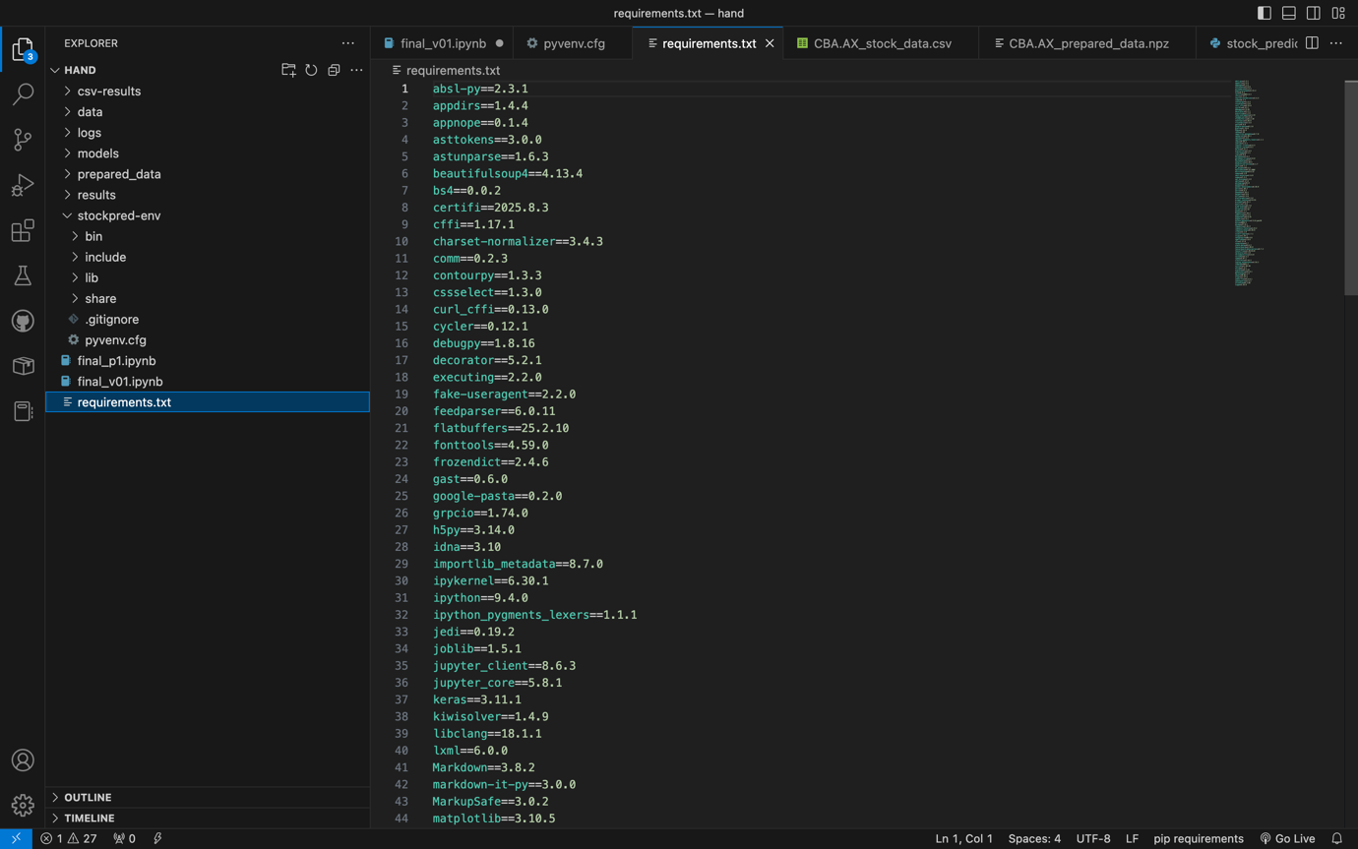

2.2 Installation Verification
All packages were successfully installed without conflicts. The virtual environment was tested to ensure both codebases could access all required dependencies.

3. Code Testing Results

3.1 Testing v0.1 Codebase
Test Environment:
- Dataset: CBA.AX stock data
Console Output Screenshot:
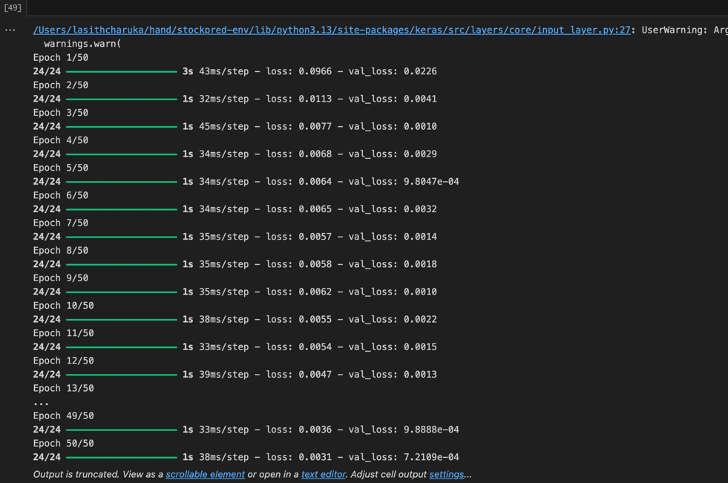
Generated Visualizations:
- Actual vs Predicted Prices Line Plot
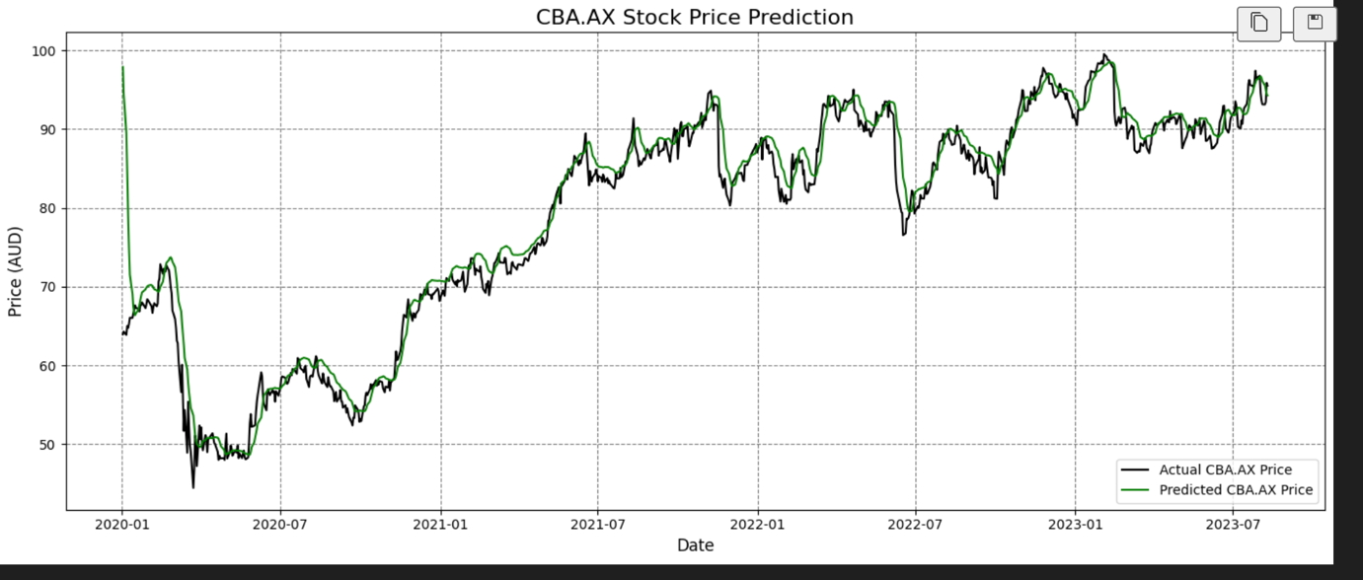
  - Black line: Actual stock prices from test period
  - Green line: Predicted prices from LSTM model
- Candlestick Chart with Predictions Overlay
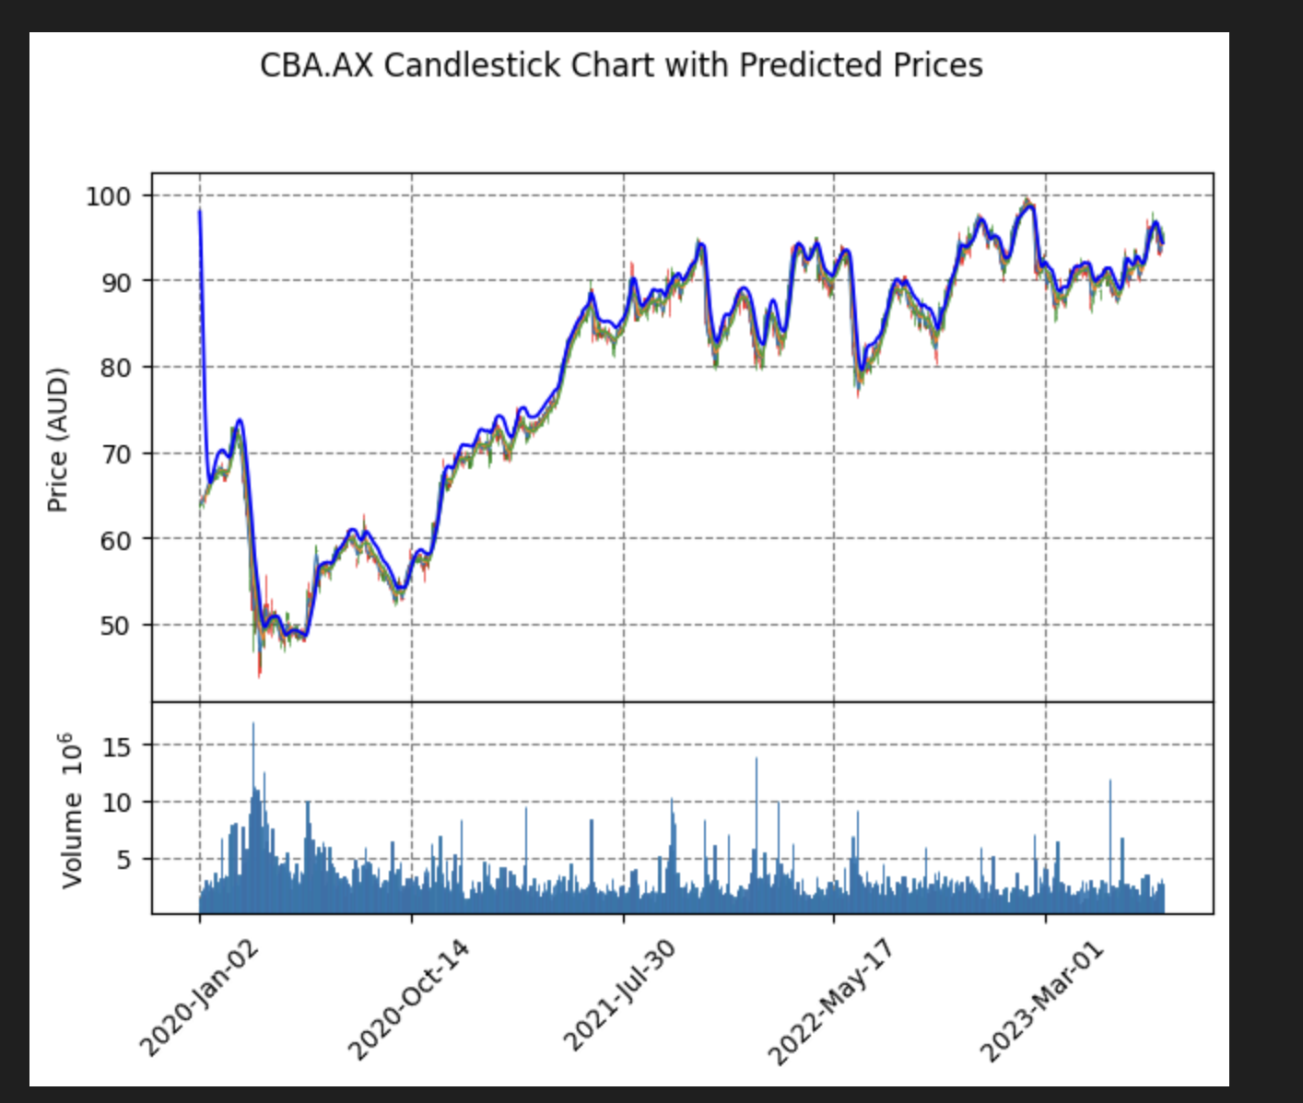
  - OHLC candlesticks with blue line overlay for predicted closing prices
- High & Low Prices with Predicted Close
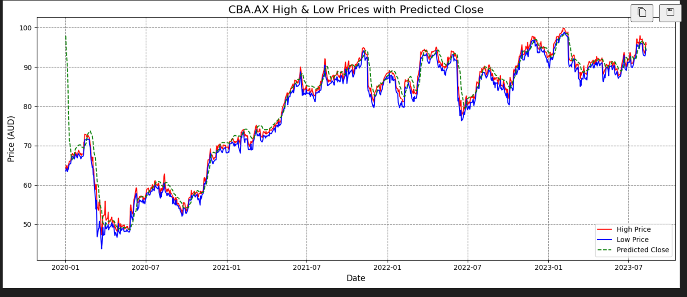
  - Red line: Daily high prices
  - Blue line: Daily low prices
  - Green dashed line: LSTM predicted closing prices

3.2 Testing P1 Codebase
Test Environment:
- Dataset: AMZN
Console Output Screenshot: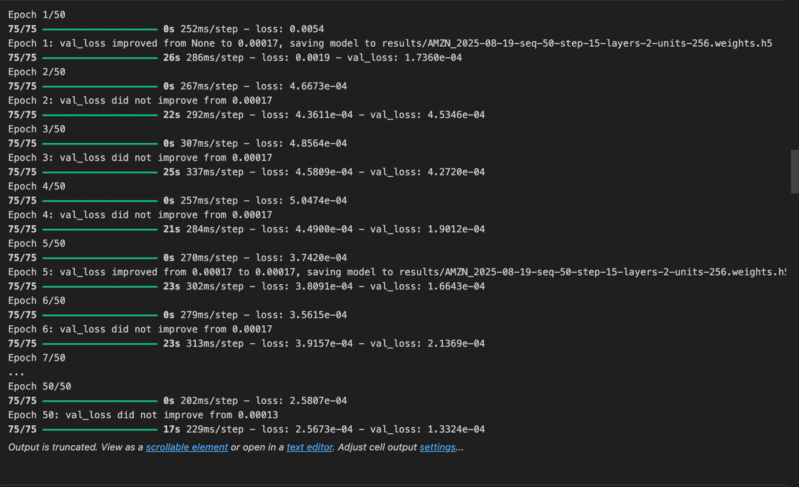
Generated Outputs:
- Final Results Graph
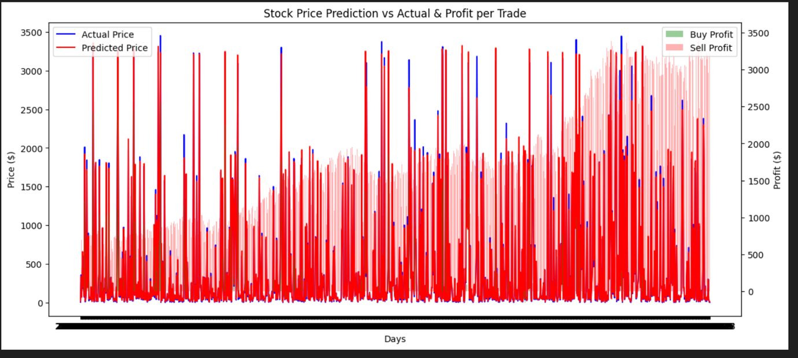
- Performance Metrics: Test Loss: 0.0001
Mean Absolute Error (original scale): 27.9857

4. Code Understanding and Analysis

4.1 v0.1 Codebase Analysis
Architecture Overview: The v0.1 implementation follows a straightforward LSTM approach for stock price prediction:
Data Flow Diagram:
Yahoo Finance Data → Data Preprocessing → Feature Engineering →
LSTM Model Training → Predictions → Visualizations
Key Components:
- Data Loading and Preparation
  - Loads historical stock data from Yahoo Finance (yfinance) for CBA.AX
  - Saves data locally to data/CBA.AX_stock_data.csv for reusability
  - Calculates MidPrice = (Open + Close) / 2 as the main feature
  - Creates target FuturePrice_60d by shifting MidPrice 60 days ahead
- Data Scaling and Sequence Generation
  - Uses MinMaxScaler to normalize prices to 0-1 range for LSTM input
  - Implements sliding window approach with PREDICTION_DAYS = 60
  - Creates 3D input sequences (samples, time steps, features)
- Model Architecture
  - Input Layer: 60-day sequences
  - Two LSTM layers with 50 units each
  - First LSTM returns sequences; second does not
  - Dropout (0.2) after each layer to prevent overfitting
  - Output Layer: Dense layer with 1 unit for next price prediction
- Training Configuration
  - Optimizer: Adam
  - Loss Function: Mean Squared Error
  - Epochs: 50
  - Batch Size: 32
  - Validation Split: 10%

4.2 P1 Codebase Analysis
Architecture Overview: The P1 implementation is more sophisticated, focusing on trading strategy evaluation:
Data Flow Diagram:
Historical Data → Feature Engineering → LSTM Training →
Predictions → Trading Simulation → Profit Analysis → Results Export
Key Components:
- Data Preparation
  - Supports both Yahoo Finance API and CSV input
  - Configurable feature selection (open, high, low, close, adjclose, volume)
  - Optional data scaling with MinMaxScaler
  - Flexible sequence length (N_STEPS parameter)
  - Date-based or random train/test splitting
- Model Construction
  - Configurable number of LSTM layers (N_LAYERS)
  - Adjustable units per layer (UNITS)
  - Optional Bidirectional LSTM support
  - Dropout layers for regularization
  - Dense output layer for price prediction
- Training Process
  - Advanced loss function: Huber Loss
  - Adam optimizer
  - Configurable batch size and epochs
  - Model checkpointing for best weights
  - TensorBoard integration for training visualization
- Trading Simulation
  - Converts predictions to buy/sell signals
  - Calculates trade profits
  - Tracks both buy and sell positions
  - Performance evaluation metrics

5. Modifications Made

5.1 Enhanced P1 Codebase
I implemented three key improvements to the P1 codebase:

5.1.1 Added Accuracy Calculation
accuracy_score = (len(final_df[final_df['sell_profit'] > 0]) +
len(final_df[final_df['buy_profit'] > 0])) / len(final_df)
Benefits:
- Provides a clear accuracy metric beyond raw profit
- Measures percentage of profitable trades
- Enables better model performance evaluation

5.1.2 Calculated Detailed Profits
total_buy_profit = final_df["buy_profit"].sum()
total_sell_profit = final_df["sell_profit"].sum()
total_profit = total_buy_profit + total_sell_profit
profit_per_trade = total_profit / len(final_df)
Benefits:
- Separates buy and sell profit analysis
- Normalizes results by number of trades
- Facilitates comparison across different datasets and time periods

5.1.3 Added Results Export to CSV
csv_results_folder = "csv-results"
if not os.path.isdir(csv_results_folder):
os.mkdir(csv_results_folder)
csv_filename = os.path.join(csv_results_folder, model_name + ".csv")
final_df.to_csv(csv_filename)
Benefits:
- Creates dedicated results folder for organization
- Automated saving per model configuration
- Enables easy analysis, sharing, and future experimentation
- Supports batch processing of multiple models

6. Comparison of Codebases

6.1 Feature Comparison Table
Aspect | v0.1 | P1 (Original) | P1 (Modified)
Primary Purpose | Price Prediction | Trading Strategy | Enhanced Trading Strategy
Data Sources | Yahoo Finance Only | Yahoo Finance + CSV | Yahoo Finance + CSV
Model Flexibility | Fixed Architecture | Highly Configurable | Highly Configurable
Loss Function | MSE | Huber Loss | Huber Loss
Output Analysis | Visual Only | Basic Profit | Detailed Profit + Accuracy
Result Storage | None | None | CSV Export
Visualization | 3 Chart Types | 1 Chart Type | 1 Chart Type
Trading Simulation | No | Yes | Yes (Enhanced)

6.2 Strengths and Weaknesses
v0.1 Strengths:
- Simple and easy to understand
- Multiple visualization types
- Good for learning LSTM basics
- Clear data preprocessing steps
v0.1 Weaknesses:
- Limited configurability
- No trading strategy evaluation
- No result persistence
- Fixed to single stock (CBA.AX)
P1 Strengths:
- Highly configurable architecture
- Trading strategy simulation
- Professional-grade features (callbacks, tensorboard)
- Flexible data handling
P1 Weaknesses (Original):
- Limited result analysis
- No accuracy metrics
- No result export functionality
- Complex for beginners
Modified P1 Advantages:
- Combines P1 flexibility with enhanced analytics
- Automated result storage for batch processing
- Comprehensive performance metrics
- Better suited for systematic strategy testing

7. Conclusion

7.1 Setup Success
The environment setup was successful, with both codebases running reliably in the isolated virtual environment. The requirements.txt file ensures reproducibility across different systems and development sessions.

7.2 Code Understanding
Through testing and analysis, I gained comprehensive understanding of both approaches:
- v0.1 provides an excellent introduction to LSTM-based stock prediction
- P1 offers a professional framework for trading strategy development
- The modifications to P1 enhance its analytical capabilities significantly

7.3 Key Learnings
- Virtual Environment Importance: Critical for managing dependencies and ensuring reproducible results
- Code Architecture Differences: v0.1 focuses on prediction accuracy, while P1 emphasizes trading profitability
- Enhancement Opportunities: The P1 codebase benefited significantly from additional analytical features
- Documentation Value: Comprehensive testing and documentation are essential for understanding complex ML projects

7.4 Next Steps
With the environment successfully set up and both codebases thoroughly understood, I am prepared to proceed with further development and experimentation in subsequent tasks.

